**PRODUCT DESIGNER - HTML5 Web, Android & IOS Application**

**Hassel free direct print from the high resolution png image without the product on it.**

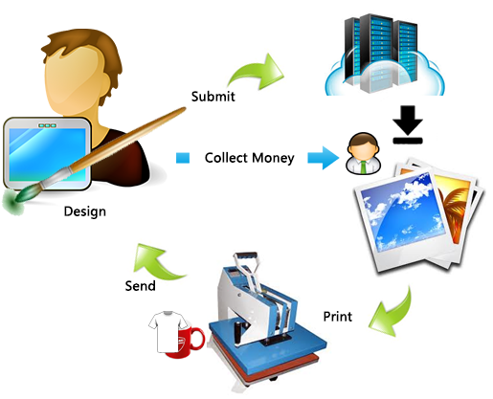

**About the app**

This is an online product designer tool or software for your customers to design or customize their interests on the products you produce and supply.

This application runs on any device which can render web pages like Windows Mobile, Android and IOS.

**Browser Compatibility**

1. Firefox
2. Google chrome
3. Safari
4. Opera
5. IE

**User Interface walk through**

|  |  |
| --- | --- |
|  | * The left panel of the designer tool is used for loading multiple item types of a particular product * Each can be given a name to display * Each item has its own price in the code base which can be configured easily by chaning **data-price="90"** and each item can be assigned one product ID **data-name="ipad cover - PID:i001"** |
|  | * The clone icon is used for cloning any particular design element with all its properties * The reset icon clears all properties of a selected design element |
|  | * The tab navigator has product list, graphic elements list, text properties, upload option for user |
|  | * Settings bar is used for changing the properties of any selected design element |
|  | * Price is updated on each element added to the design based on the price set for each element |
|  | * Text features include Color picker for touch screens * Bold, Italic, Underline * Shadow & Stroke(under improovement) * Unlimited fonts can be used from google fonts * Arc text feature enabled |

**How to add an item**

<li class="item" id="ipadCover" onclick="getNestedElements(this.id); hideSize();"><img src="images/ipadcover/i1s.png" width="69" height="54"><div class="itemName">iPad Cover</div>

<ul>

<li><img id="ipadCover1" src="images/ipadcover/i1s.png" width="45" height="35" data-price="90" data-name="ipad cover - PID:i001" style="margin-top:10px;" onclick="addItemtoStage('images/ipadcover/i1.jpg', this.id)"><br>Front</li>

<li><img id="ipadCover2" src="images/ipadcover/i2s.png" width="45" height="35" data-price="90" data-name="ipad cover - PID:i002" style="margin-top:10px;" onclick="addItemtoStage('images/ipadcover/i2.png', this.id)"><br>Front</li>

</ul>

</li>

See the above structure

The first li tag contains the information about the display item which again contains two items.

Class item is used for each item

To add one more item, you have to paste the above code into the page and update values.

**To add graphic elements do the below**

<li class="item"><img src="images/graphics/angryBird.svg" width="68" onclick="addDynamicItemtoStage(this.src, this.getAttribute('data-price')); updatePrice(this.getAttribute('data-price'));" data-price="30"><div class="itemName">Angry Bird</div></li>

See the code in index.html page and update it or add it.

**How to add google fonts**

On <https://www.google.com/fonts> page, select all the fonts you need to add

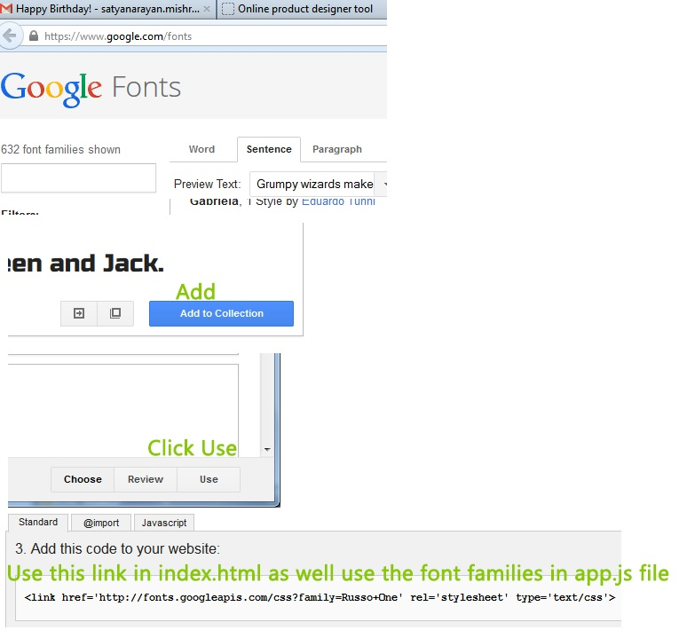

* Generate the link like below

<link href='<http://fonts.googleapis.com/css?family=Russo+One|Alegreya+Sans+SC>’ rel='stylesheet' type='text/css'>

* Add or update it to the index page where you see the similar link
* Open “**js/app.js**” file and add the font families only from the above link like

var gFonts = “Russo+One|Alegreya+Sans+SC”; Please don’t forget to remove any numbers with : for each font

* **For admin to generate the proper output image without missing fonts, admin has to download the list of fonts used above and install it on the system in which he is going to download the high resolution image. You might have to download the bold and italic versions of the fonts too.**

**How to update price for each item**

* When you are adding items in index.html page, you have an option to give the data-price for each item or graphic element
* The base price for item/product should be added to item tag
* Each graphic elements has its own data-price property which will be added to the base price
* Price for text designs need to be updated in index.html file like below

<input type="button" id="addTxtBtn" name="addTxtBtn" value="Add" onclick="addText(this.getAttribute('data-price'))" **data-price="10"** style="float:left; width:100px; height:40px !important;" />

<input type="button" id="addCTxtBtn" name="addCTxtBtn" value="Add Arc Text" onclick="addCurvText(this.getAttribute('data-price'))" **data-price="30"** style="width:100px; height:40px; float:left;" />

**How admin generates high resolution image for print**

* Once user designs and submits the item design, the user as well as the admin gets notified by email.
* The user has the item design link in his mail which he can refer in future.
* The admin will have the same link as well admin has his own tool where he can generate the image
* Then admin compares the image with the design link received and he can print.
* The image is 12x bigger as seen in the interface for best quality print

**Notification to the user as well as admin**

Once user submits the design, the user as well as the admin/the printer/product producer will receive the notifications by mail.

The mail will contain about the user details as well as the design link

Admin just have to click on the link to see the product designed and he can take print

**How to configure admin details**

Admin set up is simple

Open the **receiveDesign.php** file and update your email ID to receive the designs submitted

**How to optimize the images for items/product preview**

**2000px width X 1250px height maximum dimension of the product images**

As the design area displays high resolution product image which is scaled down one fourth of its original size, the image file size should be taken into consideration.

If you use transparent .PNG files, you cannot optimize the images for the product.

The best solution is to use .JPG/.JPEG file format with white background and the quality can be reduced till 6 or 7 during saving it from Adobe Photoshop for less image file size.

This app will run on many platforms, so better to optimize the product images before using them on the app.

The product image will ne be used for printing purpose so don’t worry about the quality of it.

And the product image is reduced by one fourth to display inside the app, so user will be able to a best quality preview even the quality is at 6.

**How to create optimized SVG images for the app to be used by users**

**700px width X 700px height maximum dimension of the SVG graphic images**

SVG images are used in the app as graphic elements for design elements so that the quality of print will be good.

But all SVG images need optimized before you upload it to the app for the best use. If you use a random SVG which has complex structure like mesh or filters it will be difficult for the app to render it on a high resolution image.

Creating SVG image for the app is simple by using Adobe Illustrator. Open your SVG image in illustrator and ungroup everything.

Make the stage size same as the image content.

Do the changes or add your own elements inside the stage

Group everything and save it as SVG image.

Open it in a browser to test if it is rendering properly.

**How to integrate the app on your server**

You can put the complete files inside a folder on your server and then call the index.html for display.

All the generated design files and stored at the root of the application to make it functional for future reference as well accessing them for generating the high resolution image for print.

Install all the fonts used in the app on the system where you are generating the high resolution image. Otherwise you will not get the fonts used by the designer in the final high resolution image.

The high resolution image is 12 times bigger than the size you are seeing in the app.

The high resolution image contains blank pixels (transparent pixels) which need to be removed in Adobe Photoshop before printing.

This does not contain the product image so you can directly print the design on any surface.

For admin tool to work please use **Firefox 27+ only**

But, Application is working on all browsers.

For assistance or installation for a small fee, please reach us at

[Mitrabinda.jvmba@gmail.com](mailto:Mitrabinda.jvmba@gmail.com)

[Satya4satyanm@gmail.com](mailto:Satya4satyanm@gmail.com)

Add us on gtalk or skype at **satya4satyanm**